- How long would it take to watch all of Game of Thrones in minutes 3,810

- Cleveland Browns Quarterbacks – 63 according to https://en.wikipedia.org/wiki/List_of_Cleveland_Browns_starting_quarterbacks

- How many people were employed in the rubber industry in Akron at its peak 85,000 https://ohiohistorycentral.org/w/Rubber_Industry

- Number of ping pong balls in a C-5 Galaxy airplane (largest airplane in the US Air Force industry) 25 million

- How many words can be made out of the word Dalmatian? 130 words https://wordmaker.info/how-many/dalmatian.html

- How far away is Akron, CO from Akron, OH? 1,265 miles (18 hours and 17 minutes, 4,817 minutes)
https://www.mapquest.com/directions/from/us/oh/akron/to/us/co/akron

- How many pounds of fries does McDonald’s sell globally per day? 9 Million
https://www.factretriever.com/mcdonalds-food-facts

- How many miles do buses and metros travel for APS? 1,023,050 Miles
https://www.akronschools.com/UserFiles/Servers/Server_409079/File/District/About/District%20Facts%20and%20Stats/APS%20Facts%20and%20Stats%202017-18.pdf

- How many sheets of paper are in one pound? 500 sheets
https://home.howstuffworks.com/question329.htm

- In LaMans France they host a 24-hour race. Teams are formed to race cars for 24 hours. How many kilometers were covered by the fastest team in 24 hours? 4,968 km

- How many seeds does a giant sunflower make? 1080. https://bybio.wordpress.com/2012/09/30/how-many-seeds-in-a-sunflower-seed-head/

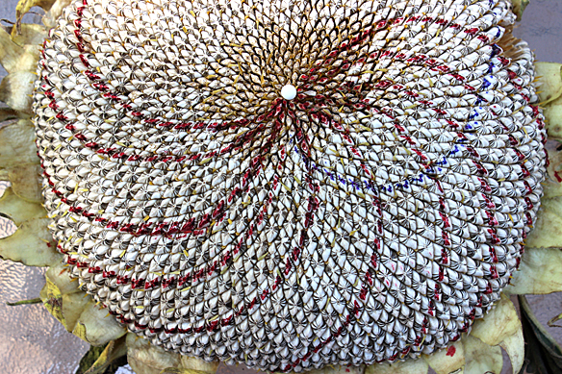

- Volume of Lake Erie in cubic miles? Approx. 115 cubic miles

